## Practice Test 2

### Question 1

Unattempted

Domain :Describe AI workloads and considerations

Please select all options that are NOT the key elements of Artificial Intelligence.

A.

**Machine Learning**

B.

**Anomaly Detection**

C.

**Computer Vision**

D.

**Object Detection**

E.

**Natural Language Processing**

F.

**Conversational AI**

G.

**Automated Machine Learning**

**Explanation:**

**Correct Answers: D and G**

There are five key elements of Microsoft Artificial Intelligence.

* **Machine Learning** - the foundation of AI systems.
* **Anomaly Detectio**n - tools and services for identification of unusual activities.
* **Computer Vision** - tools and services to understand and recognize objects in images, video, faces, and text.
* **Natural Language Processing** - tools and services for language understanding: text, speech, text analysis, and translation.
* **Conversational AI** - tools and services for intelligent conversation.
* **Option D is correct.**Object Detection is one of the common tasks of Computer Vision and is not the key element of Artificial Intelligence.
* **Options G is correct.** Automated Machine Learning is a feature of Machine Learning and is not the key element of Artificial Intelligence.

All other options are incorrect because they are the key elements of Artificial Intelligence.

For more information about the key elements of AI, please visit the below URL-

* <https://docs.microsoft.com/en-us/learn/modules/get-started-ai-fundamentals/1-introduction>

### **Question 2**

Unattempted

Domain :Describe AI workloads and considerations

You created an AI solution. Along with solution deployment, you provided information about the solution's possibilities and limitations. By providing this information, what principle for responsible AI did you comply with?

]A.

**Fairness**

]B.

**Reliability and safety**

]C.

**Privacy and security**

]D.

**Transparency**

]E.

**Inclusiveness**

]F.

**Accountability**

**Explanation:**

**Correct Answer: D**

Microsoft recognizes six principles of responsible AI.

Fairness, Reliability and safety, Privacy and security, Transparency, Inclusiveness Accountability.

The principle of Transparency helps people to understand how to use AI solutions, their behavior, possibilities, and limitations.

All other options are incorrect.

For more information about guiding principles for responsible AI, please visit the below URLs-

* <https://www.microsoft.com/en-us/ai/responsible-ai?activetab=pivot1:primaryr6>
* <https://docs.microsoft.com/en-us/learn/modules/responsible-ai-principles/4-guiding-principles>

### **Question 3**

Unattempted

Domain :Describe fundamental principles of machine learning on Azure

You are working for a car dealership. Your boss asks you to provide him information about how many blue cars he needs to order for the next quarter.

You decide to create an ML model and choose an unsupervised machine learning approach.

Will this help you to achieve your goal?

]A.**Yes**

]B.**No**

**Explanation:**

**Correct Answer: B**

Your task is to provide a numeric prediction. You can achieve this by creating a regression model based on the blue cars’ historical sales data from previous quarters. A Regression and Classification modeling types are two parts of Supervised machine learning. Only Clustering belongs to Unsupervised machine learning. If you choose the Unsupervised machine learning approach, you will not achieve your goal.

For more information about Supervised and Unsupervised ML, please visit the below URL-

* <https://azure.microsoft.com/en-us/overview/what-is-machine-learning-platform/#benefits>.

### **Question 4**

Unattempted

Domain :Describe fundamental principles of machine learning on Azure

You are working for a car dealership. Your boss asks you to provide him forecast information. Will the new car model be successful or not? The new model has a variety of engine improvements, more comfortable seats, and a sunroof. You compiled the list of data about previous successful models with their characteristics and sales numbers.

What should you do in the pre-processing data stage that would help you predict the new model’s success?

]A.

**Data selection**

]B.

**Training set selection**

]C.

**Data for model evaluation selection**

]D.

**Feature selection**

]E.

**Data classification**

**Explanation:**

**Correct Answer: D**

During pre-processing, you need to work with data to select features that influence the label prediction. In this problem, features are the engine characteristics (power or volume), seat comforts, etc. They could help the ML model to predict the success of the new car model. Maybe the sunroof is not essential for predicting the label, and we need to discard this feature from the final set of features that we will use for model training.

In short, Feature selection helps us to narrow down the features that are important for our label prediction and discard all features that don’t play or play a minimal role in a label prediction. As a result, our trained model and prediction will be more efficient.

All other options are incorrect because they are parts of the different data processing events that are irrelevant to the pre-processing (Training set selection or Data for model evaluation selection) or too generic (Data selection or Data Classification).

For more information about Feature selection, please visit the below URL-

* <https://docs.microsoft.com/en-us/azure/machine-learning/team-data-science-process/select-features>.

### **Question 5**

Unattempted

Domain :Describe fundamental principles of machine learning on Azure

You created a classification model with four possible classes.

What will be the size of the confusion matrix?

]A.

**2x2**

]B.

**3x3**

]C.

**4x4**

]D.

**6x6**

]E.

**10x10**

**Explanation:**

**Correct Answer: C**

The confusion matrix provides a tabulated view of predicted and actual values for each class. If we are predicting the classification for four classes, our confusion matrix will have a 4x4 size.

All other options are incorrect.

For more information about the Confusion matrix, please visit the below URL-

* <https://docs.microsoft.com/en-us/azure/machine-learning/how-to-understand-automated-ml#confusion-matrix>.

### **Question 6**

Unattempted

Domain :Describe fundamental principles of machine learning on Azure

When you prepare data for the model training, you have to use your domain knowledge to select the label (or labels), features, and scale and normalize them.

What is the generic name for the process that includes all the steps mentioned above?

]A.

**Feature selections**

]B.

**Data normalization**

]C.

**Model training**

]D.

**Featurization**

]E.

**Missing data handling**

**Explanation:**

**Correct Answer: D**

Data pre-processing involves various techniques, such as, scaling, normalization or feature engineering, etc. calls **featurization.**

* **Option A is incorrect** because Feature selection is one of the elements of featurization.
* **Option B is incorrect** because Data normalization is also one of the elements of featurization.
* **Option C is incorrect** because Model Training is the next predictive modeling step after featurization.
* **Option E is incorrect** because Missing data handling is one of the elements of featurization.

For more information about Featurization, please visit the below URLs-

* <https://docs.microsoft.com/en-us/azure/machine-learning/concept-automated-ml#feature-engineering>
* <https://docs.microsoft.com/en-us/azure/machine-learning/how-to-configure-auto-features#featurization>

### **Question 7**

Unattempted

Domain :Describe fundamental principles of machine learning on Azure

What are the four types of Compute resources you can use in Azure Machine Learning Studio?

Please select all that apply.

A.

**Compute Instances**

B.

**Automated ML instances**

C.

**Compute clusters**

D.

**Inference clusters**

E.

**Classification clusters**

F.

**Attached compute**

G.

**AKS Cluster instances**

**Explanation:**

**Correct Answers: A, C, D and F**

When you open Compute blade in Microsoft Azure Machine Learning Studio, you can see all four compute resources.

**Microsoft Azure Machine Learning 
New 
Home 
Author 
B 
Notebooks 
Automated ML (preview) 
6% 
Designer (preview) 
Assets 
Datasets 
Experiments 
Models 
Endpoints 
Manage 
Compute 
g Datastores 
Data Labeling 
whizlabs > 
Compute 
Compute 
Compute instances 
Compute clusters 
Inference clusters 
Attached compute 
Get started with Azure Machine Learning notebooks and R 
scripts by creating a compute instance 
Choose from a selection of CPU or GPI-J instances preconfigured with popular 
tools such as JupyterLab, Jupyter, and RStudio, ML packages, deep learning 
frameworks, and GPIJ drivers. Learn more 
Create 
View Azure Machine Learning tutorials **

* **Option B is incorrect**because Automated ML instances are the generic ML instance.
* **Option G is incorrect** because AKS Cluster Instance is the generic representation of the Azure Kubernetes cluster.

For more information about Azure ML Studio compute resources, please visit the below URLs-

* <https://docs.microsoft.com/en-us/azure/machine-learning/how-to-create-attach-compute-studio#portal-create>
* <https://docs.microsoft.com/en-us/learn/modules/use-automated-machine-learning/create-compute>

### **Question 8**

Unattempted

Domain :Describe features of computer vision workloads on Azure

You created a Custom Vision model. You want your model to detect trained objects on the photos.

What information will you get about each object if you are using an object detection model?

Please select all that apply.

A.

**Image type**

B.

**Bounding box**

C.

**Image category**

D.

**Class name**

E.

**Probability score**

F.

**Content name**

**Explanation:**

**Correct Answers: B, D and E.**

Object detection is the form of ML that helps to recognize objects on the images. Each recognizable object will be put in the bounding box with the class name and probability score.

Here is the Microsoft information about the object detection model.

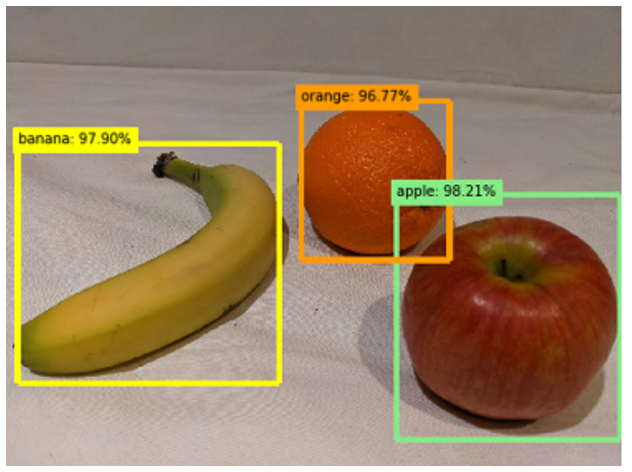

All other options are incorrect because they are not part of the object detection model’s return information.

For more information about Object detection, please visit the below URL-

* <https://docs.microsoft.com/en-us/learn/modules/detect-objects-images-custom-vision/1-introduction>.

### **Question 9**

Unattempted

Domain :Describe features of computer vision workloads on Azure

The application scans a document with a lot of pages. It returns the following information for each page, such as, page information, lines information, and words for each line with a confidence level.

What API does the application use to scan the document?

]A.

**OCR**

]B.

**NLP**

]C.

**Read**

]D.

**Text Analytics**

]E.

**LUIS**

**Explanation:**

**Correct Answer: C**

Read API is part of Computer Vision services. It helps to "read" texts within predominantly document images. Read API is an asynchronous service specially designed for the heavy on text images or documents with many distortions. It produces a result that includes: page information for each page, including page size and orientation; information about each line on the page, and information about each word in each line, including the bounding box of each word as an indication of the word position in the image.

* **Option A is incorrect** since OCR API is an asynchronous service for recognizing small amounts of text in the images. It returns regions of the text in the image, lines of the text in the region, and words in each line.
* **Option B is incorrect**since Natural Language Processing (NLP) is one of the key elements of Artificial Intelligence and is not the part of Computer Vision that deals with text extraction from the images.
* **Option D is incorrect** since Text Analytics is part of Natural Processing Language (NLP) and is not the part of Computer Vision that deals with text extraction from the images.
* **Option E is incorrect** since Language Understanding Intelligent Service (LUIS) is the part of Natural Processing Language (NLP) and is not part of Computer Vision that deals with text extraction from the images.

For more information about Read API, please visit the below URLs-

* <https://docs.microsoft.com/en-us/azure/cognitive-services/computer-vision/concept-recognizing-text>
* <https://docs.microsoft.com/en-us/learn/modules/read-text-computer-vision/2-ocr-azure>

### **Question 10**

Unattempted

Domain :Describe features of computer vision workloads on Azure

You created a Custom Vision model using the Custom Vision portal.

What information do you need to provide to the developers to use this model?

Please select all that apply.

A.

**Project ID**

B.

**Security Key**

C.

**Model name**

D.

**Prediction key**

E.

**Cognitive Service key**

F.

**Prediction Endpoint**

**Explanation:**

**Correct Answers: A, C, D and F.**

If you create a Cognitive Service to train and publish the Custom Vision model, you can provide a Cognitive Service endpoint and Cognitive Service key to the developers for access to the model. But if you use the Custom Vision portal or create a Custom Vision resource within Cognitive Service, you will have two separate resources to train and publish a model. In this case, you need to provide the four pieces of information to the developers, such as, Project ID, Model name, Prediction Key, and Prediction Endpoint.

* **Option B is incorrect**since Security Key is just a generic key that isn't applicable in this case.
* **Option E is incorrect** since we need to provide the pair: Cognitive Service endpoint and Cognitive Service key. Only one of them, a Cognitive Service key, will not work.

For more information about Custom Vision, please visit the below URLs-

* <https://docs.microsoft.com/en-us/azure/cognitive-services/custom-vision-service/home>
* <https://docs.microsoft.com/en-us/learn/modules/classify-images-custom-vision/2-azure-image-classification>

### **Question 11**

Unattempted

Domain :Describe features of Natural Language Processing (NLP) workloads on Azure

You are working at the hotel chain. You are planning to apply Natural Language Processing for the sentiment analysis of the customer reviews.

What sentiment score should you expect for the following review- "The prices were ridiculously high. We could stay at the palace for that price! The water in the shower was cold, no hot water whatsoever"?

]A.

**1**

]B.

**0.5**

]C.

**2**

]D.

**0.9**

]E.

**0.1**

**Explanation:**

**Correct Answer: E.**

Sentiment analysis is producing the sentiment score between 0 and 1. A score close to 0 means a negative sentiment, and close to 1 - positive. And in cases with the neutral or undefined sentiment, the score is 0.5. In this problem, the review is negative, and we should expect a score of 0.1.

All other options are incorrect.

For more information about Sentiment Analysis, please visit the below URL-

* <https://docs.microsoft.com/en-us/learn/modules/analyze-text-with-text-analytics-service/2-get-started-azure>.

### **Question 12**

Unattempted

Domain :Describe features of Natural Language Processing (NLP) workloads on Azure

What are the four types of entities that you can create during the authoring of the LUIS Application?

A.

**Machine-Learned**

B.

**List**

C.

**FAQ document**

D.

**RegEx**

E.

**Chit-chat**

F.

**Pattern.any**

G.

**Alternative phrasing**

**Explanation:**

**Correct Answers: A, B, D and F**

We need to create intents, entities, and train a model during an authoring phase for a Language Understanding application. There are four types of entities that we can create, such as, Machine-Learned, List, RegEx, and Pattern.any.

All other options are incorrect because they are parts of creating a Knowledge base for Q&A Maker and Azure Bot Service.

For more information about LUIS, please visit the below URLs-

* <https://docs.microsoft.com/en-us/learn/modules/create-language-model-with-language-understanding/2-get-started>
* <https://www.luis.ai/>

### **Question 13**

Unattempted

Domain :Describe features of conversational AI workloads on Azure

What components do you need to create a simple Web Chat Bot?

A.

**Entities**

B.

**Knowledge base**

C.

**Utterances**

D.

**Bot Service**

E.

**LUIS**

F.

**Text Analytics**

**Explanation:**

**Correct Answers: B and D**

To create a simple Web Chat Bot, you need just two components, such as, Knowledge Base and Bot Service.

We can create a Knowledge base from web site information or FAQ documents, etc. Usually, the Knowledge base is a list of Question and answer pairs. Bot Service provides an interface to interact with a Knowledge Base from different channels.

* **Options A and C are incorrect** because Entities and Utterances are the parts of LUIS authoring and are not components of Web Chat Bot.
* **Option E is incorrect**since Language Understanding Intelligent Service (LUIS) is Natural Processing Language (NLP) service and is not a Web Chat Bot component.
* **Option F is incorrect** since Text Analytics is  Natural Processing Language (NLP) service and is not a Web Chat Bot component.

For more information about Bot Service, please visit the below URLs-

* <https://docs.microsoft.com/en-us/learn/modules/build-faq-chatbot-qna-maker-azure-bot-service/1-introduction>
* <https://azure.microsoft.com/en-us/services/bot-service/>

### **Question 14**

Unattempted

Domain :Describe features of conversational AI workloads on Azure

You want to build a personal virtual assistant. What service will you use to connect your assistant with various input channels and devices?

]A.

**Computer Vision**

]B.

**Azure Bot Service**

]C.

**QnA Maker**

]D.

**LUIS**

]E.

**Speech to Text**

]F.

**Text Analytics**

**Explanation:**

**Correct Answer: B**

Azure Bot Service connects various channels and devices that users can use for their inquiries.

The Microsoft documentation provides the following information about Virtual Assistant.

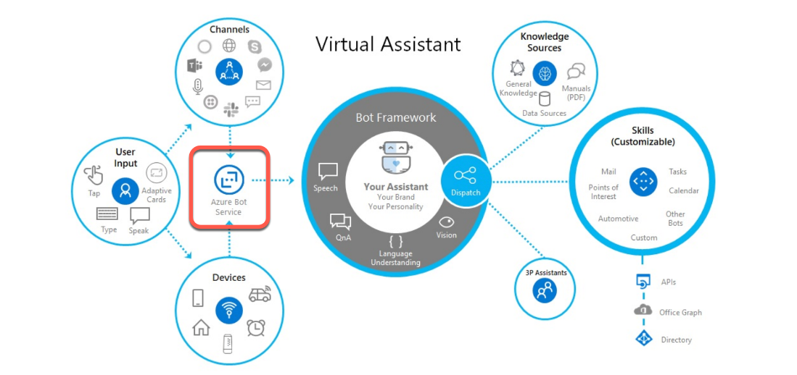

As you can see on the left side, Azure Bot Service serves as data input for Virtual Assistant.

All other options are incorrect.

For more information about Personal Assistant, please visit the below URLs-

* <https://docs.microsoft.com/en-us/azure/bot-service/bot-builder-virtual-assistant-introduction?view=azure-bot-service-4.0>

### **Question 15**

Unattempted

Domain :Describe features of conversational AI workloads on Azure

You build a Bot using the Bot Framework and Azure Bot Service. You want to extend the capabilities of your Bot.

What will you use to achieve your goal?

]A.

**Custom Vision**

]B.

**Language Translation**

]C.

**Chit-Chat**

]D.

**Skills**

]E.

**Text to Speech**

]F.

**FAQ Document**

**Explanation:**

**Correct Answer: D**

Using Bot Framework Skills, you can easily extend the capabilities of your Bot. Skills are like standalone bots that focus on a specific function, like Calendar, To-Do, Point of Interest, etc.

In the Virtual Assistant design, Bot Framework dispatches actions to Skills.

Here is the Microsoft information about Bot Framework and Skills as parts of Virtual Assistant.

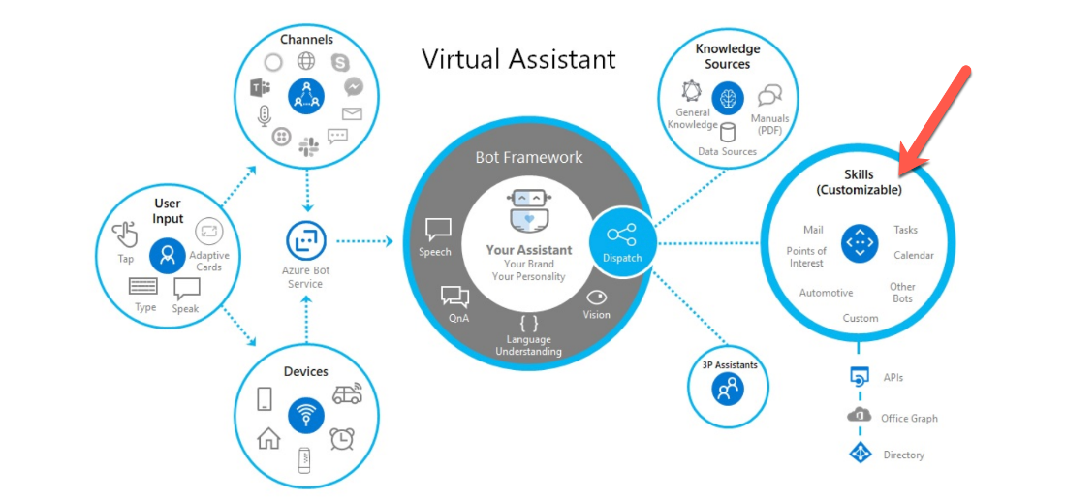

* **Option A is incorrect** because Custom Vision is one of the Computer Vision services and potentially can extend Bot functionality as part of the Skill.
* **Options B and E are incorrect** because Language Translation and Text to Speech are Natural Language Processing services and can potentially extend Bot functionality as part of the Skill.
* **Options C and F are incorrect** because Chit-Chat and FAQ documents are the parts for creating a Knowledge base for Q&A Maker and Azure Bot Service.

For more information about Bot Framework Skills, please visit the below URLs-

* <https://microsoft.github.io/botframework-solutions/overview/skills/>
* <https://microsoft.github.io/botframework-solutions/overview/virtual-assistant-solution/>

### **Question 16**

Unattempted

Domain :Describe AI workloads and considerations

What are the main features and capabilities of Azure Machine Learning?

Please select all options that apply.

A.

**Anomaly Detection**

B.

**Pipelines**

C.

**Object Detection**

D.

**Automated machine learning**

E.

**Azure Machine Learning designer**

F.

**Text Analytics**

G.

**Data and compute management**

**Explanation:**

**Correct Answers: B, D, E, and G**

Azure Machine Learning is the foundation for Artificial Intelligence service. It includes four features and capabilities.

* **Automated machine learning** - automated creation of ML models based on your data; doesn't require any data science experience.
* **Azure Machine Learning designer** - a graphical interface for no-code creation of the ML solutions
* **Data and Compute managemen**t - cloud-based tools for data science professionals,
* **Pipelines** - visual designer for creating ML tasks workflow

Option A is incorrect. Anomaly Detection - is one of the key elements of Artificial Intelligence, and it is not a feature of Machine Learning.

Option C is incorrect. Object Detection is one of Computer Vision's common tasks and is not part of Machine Learning.

Options G is incorrect. Text Analytics - is a feature of Natural language processing and is not a part of Machine Learning.

For more information about the features and capabilities of Machine Learning, please visit the below URL-

* <https://docs.microsoft.com/en-us/learn/modules/get-started-ai-fundamentals/2-understand-machine-learn>

### **Question 17**

Unattempted

Domain :Describe AI workloads and considerations

Microsoft defines this Computer Vision technique in the following way.

"An advanced machine learning technique in which individual pixels in the image are classified according to the object to which they belong."

What is the name of this common Compute Vision task?

]A.

**Image Classification**

]B.

**Semantic Segmentation**

]C.

**Object Detection**

]D.

**Image Analysis**

]E.

**Face recognition**

**Explanation:**

**Correct Answer: B**

According to Microsoft,

**"Semantic segmentation** is an advanced machine learning technique in which individual pixels in the image are classified according to the object to which they belong."

All other options are also common Computer Vision tasks.

* **Option A is incorrect.** Image Classification classifies images based on their content.
* **Option C is incorrect.**Object Detection classifies individual objects within an image.
* **Option D is incorrect.** Image Analysis extracts information from the images.
* **Option F is incorrect**. Face detection is face detection, analysis, and recognition of the human faces in Images.

For more information about the common Computer Vision tasks, please visit the below URLs-

* <https://azure.microsoft.com/en-us/services/cognitive-services/computer-vision/#features>
* <https://docs.microsoft.com/en-us/learn/modules/get-started-ai-fundamentals/2-understand-machine-learn>

### **Question 18**

Unattempted

Domain :Describe AI workloads and considerations

You created an AI solution that qualifies customers for a bank loan. The solution provides different results for the people living in cities and rural areas.

What responsible AI principle does your solution violate?

]A.

**Transparency**

]B.

**Reliability and safety**

]C.

**Privacy and security**

]D.

**Inclusiveness**

]E.

**Fairness**

]F.

**Accountability**

**Explanation:**

**Correct Answer: E**

Microsoft recognizes six principles of responsible AI.

Fairness, Reliability and safety, Privacy and security, Transparency, Inclusiveness and Accountability.

The principle of Fairness directs AI solutions to treat everybody fairly, independently from gender, race, or any bias.

All other options are incorrect.

For more information about guiding principles for responsible AI, please visit the below URLs​​-​

* <https://www.microsoft.com/en-us/ai/responsible-ai?activetab=pivot1:primaryr6>
* <https://docs.microsoft.com/en-us/learn/modules/responsible-ai-principles/4-guiding-principles>

### **Question 19**

Unattempted

Domain :Describe AI workloads and considerations

You are building your AI solution within the framework of governance and organizational requirements that reflect defined legal and ethical standards.

What responsible AI principle are you following?

]A.

**Privacy and security**

]B.

**Transparency**

]C.

**Inclusiveness**

]D.

**Accountability**

]E.

**Reliability and safety**

]F.

**Fairness**

**Explanation:**

**Correct Answer: D**

Microsoft recognizes six principles of responsible AI.

Fairness, Reliability and safety, Privacy and security, Transparency, Inclusiveness and Accountability.

The principle of Accountability directs AI solutions to follow governance and organizational norms.

All other options are incorrect.

For more information about guiding principles for responsible AI, please visit the below URLs-

* <https://www.microsoft.com/en-us/ai/responsible-ai?activetab=pivot1:primaryr6>
* <https://docs.microsoft.com/en-us/learn/modules/responsible-ai-principles/4-guiding-principles>

### **Question 20**

Unattempted

Domain :Describe fundamental principles of machine learning on Azure

You work for a major airline. The airline is planning to implement new services for the premium cabin. You have been asked to predict whether elite members of a frequent flyer program favor these services or not.

You decided to implement Clustering modeling.

Does this decision help you to achieve your goal?

]A.**Yes**

]B.**No**

**Explanation:**

**Correct Answer: B**

Your task is to provide a classification prediction, like, answer the binary Yes or No Question . You can achieve this by creating a Classification model based on the data from historical reviews.

The Clustering is a Machine Learning form that groups items based on some common properties.

For more information about Classification ML, please visit the below URL-

* <https://docs.microsoft.com/en-us/learn/modules/create-classification-model-azure-machine-learning-designer/introduction>.

### **Question 21**

Unattempted

Domain :Describe fundamental principles of machine learning on Azure

When you are creating a Clustering Model, what common ML algorithm are you using?

]A.

**Multicast Logistic Regression**

]B.

**K-means**

]C.

**Linear Regression**

]D.

**Two-Class Neural Network**

]E.

**Decision Forest Regression**

**Explanation:**

**Correct Answer: B**

The Clustering is a Machine Learning form that groups items based on some common properties.

The most common Clustering algorithm is K-means Clustering.

* **Option A is incorrect** because the Multicast Logistic Regression is a Classification algorithm based on a decision forest algorithm.
* **Option C is incorrect** because the Linear Regression algorithm is a Regression algorithm based on a linear regression model.
* **Option D is incorrect** because the Two-Class Neural Network is a Classification algorithm based on a neural network algorithm.
* **Option E is incorrect**because the Decision Forest Regression algorithm is a Regression algorithm based on a decision forest algorithm.

For more information about K-means Clustering, please visit the below URL-

* <https://docs.microsoft.com/en-us/learn/modules/create-clustering-model-azure-machine-learning-designer/create-training-pipeline>.

### **Question 22**

Unattempted

Domain :Describe fundamental principles of machine learning on Azure

You need to train and test your model. You prepared data for model training. You decided to use this data for the model training and then for the model validation.

Does this decision help you to achieve your goal?

]A.**Yes**

]B.**No**

**Explanation:**

**Correct Answer: B**

You have to split your data into two sets: the first is for model training, and the second for model testing. If you are using Automated machine learning, it does it for you automatically as part of data preparation and model training.

For more information about Model training and testing, please visit the below URL-

* <https://docs.microsoft.com/en-us/learn/modules/create-regression-model-azure-machine-learning-designer/create-training-pipeline>.

### **Question 23**

Unattempted

Domain :Describe fundamental principles of machine learning on Azure

You need to create a Classification model using Azure ML. What types of Algorithms will you use?

Please select all that apply.

A.

**Two-class logistic regression**

B.

**Linear Regression**

C.

**K-means clustering**

D.

**Multiclass logistic regression**

E.

**Decision forest regression**

F.

**Multiclass decision forest**

**Explanation:**

**Correct Answers: A, D, and F**

All algorithms in the ML Classification family include the word "class" in their names, like

Two-**class** logistic regression, Multi**class** logistic regression, or Multi**class** decision forest.

Regression Algorithm Family has the word "regression" in their names without class, like Linear **Regression**or Decision forest **regression.**

And there is only one algorithm for Clustering: K-means clustering.

* **Options B and E are incorrect** because both Linear Regression and Decision forest regression algorithms are Regression algorithms.
* **Option C is incorrect** because K-means clustering is a Clustering algorithm.

For more information about Azure ML algorithms, please visit the below URL-

* <https://docs.microsoft.com/en-us/azure/machine-learning/how-to-select-algorithms>.

### **Question 24**

Unattempted

Domain :Describe fundamental principles of machine learning on Azure

What are the four typical steps of data transformation for model training?

Please select all that apply.

A.

**Feature selection**

B.

**Finding and removing data outliers**

C.

**Split data**

D.

**Impute missing values**

E.

**ML algorithm selection**

F.

**Normalize numeric features**

**Explanation:**

**Correct Answers: A, B, D and F**

After we ingest the data, we need to do a data preparation or transformation before supplying it for model training. There are four typical steps for data transformation such as Feature selection, Finding and removing data outliers, Impute missing values, and Normalize numeric features.

* **Option C is incorrect**because Split data is coming after data transformation.
* **Option D is incorrect**because ML algorithm selection data is coming after data transformation and Split Data steps.

For more information about Azure ML algorithms, please visit the below URL-

* <https://docs.microsoft.com/en-us/learn/modules/create-regression-model-azure-machine-learning-designer/explore-data>.

### **Question 25**

Unattempted

Domain :Describe fundamental principles of machine learning on Azure

What steps are NOT part of the model training stage after data transformation?

Select all that apply.

A.

**Feature selection**

B.

**Algorithm selection**

C.

**Normalize numeric features**

D.

**Provide a labeled dataset**

E.

**Split data**

F.

**Model Training**

G.

**Scoring results**

**Explanation:**

**Correct Answers: A and C**

* **Options A and C are correct**because Feature Selection and Normalize numeric features are steps from the data transformation stage. They are NOT part of the model training stage.

Here is a generic workflow for model training after the data pre-processing or transformation stage.

1. After we prepared and labeled data for the model training, we are ready to use this data set for the training.
2. We need to Split data before feeding it to a model training module.
3. We also need to select our ML algorithm to reflect our goals and be compatible with the provided data.
4. After that, we run the model training and produce a scoring result.

For more information about Azure ML model training, please visit the below URL-

* <https://docs.microsoft.com/en-us/azure/machine-learning/algorithm-module-reference/train-model>.

### **Question 26**

Unattempted

Domain :Describe features of computer vision workloads on Azure

You install a Visual product search application on your mobile. The application searches products based on their images that you capture by mobile camera.

What Computer Vision common task this application uses for the product search?

]A.

**Object detection**

]B.

**Semantic segmentation**

]C.

**Image classification**

]D.

**Face detection**

]E.

**Image Analysis**

**Explanation:**

**Correct Answer: C**

You use your camera to capture a picture of the product. An application identifies this product utilizing the Image classification model and submits it for a search.

The Image classification model helps to classify images based on their content.

* **Option A is incorrect** because the Object detection model helps to identify objects and their boundaries within the image.
* **Options B is incorrect** because the Semantic segmentation model helps classify pixels to the objects they belong to.
* **Option D is incorrect** because the Face detection is a Computer vision technique that helps detect and recognize people's faces.
* **Options E is incorrect** because the Image Analysis helps extract information from the images, tag them, and create a descriptive image summary.

For more information about Image classification, please visit the below URL-

* <https://docs.microsoft.com/en-us/learn/modules/classify-images-custom-vision/1-introduction>.

### **Question 27**

Unattempted

Domain :Describe features of computer vision workloads on Azure

You implement an aerial image processing application to identify the flooded areas.

What common Computer Vision task is this application using?

]A.

**Object detection**

]B.

**Semantic segmentation**

]C.

**Image classification**

]D.

**Face detection**

]E.

**Image Analysis**

**Explanation:**

**Correct Answer: B**

When the application processes images, it uses Semantic segmentation to classify pixels that belong to the particular object (in our case, flooded areas) and highlights them.

* **Option A is incorrect**because the Object detection model helps to identify objects and their boundaries within the image.
* **Options C is incorrect** because the Image classification model helps to classify images based on their content.
* **Option D is incorrect** because the Face detection is a Computer vision technique that helps detect and recognize people's faces.
* **Options E is incorrect** because the Image Analysis helps extract information from the images, tag them, and create a descriptive image summary.

For more information about Object detection, please visit the below URL-

* <https://docs.microsoft.com/en-us/learn/modules/get-started-ai-fundamentals/4-understand-computer-vision>.

### **Question 28**

Unattempted

Domain :Describe features of computer vision workloads on Azure

What tasks does Computer Vision Cognitive service include?

Please select all that apply.

A.

**Translator text**

B.

**Read the text in the image**

C.

**Detects Objects**

D.

**Processes forms**

E.

**Identifies Landmarks**

F.

**Find Similar Faces**

G.

**Categorize image**

**Explanation:**

**Correct Answers: B, C, E and G.**

Computer Vision service is one of the main areas of Artificial Intelligence. It belongs to the group of Azure Computer vision solutions such as Computer Vision service, Custom Vision Service, Face service, and Form Recognizer.

Computer Vision service works with images. This service brings sense to the image pixels by using them as features for ML models. These predefined models help categorize and classify images, detect and recognize objects, tag, and identify them. Computer Vision can "read" a text in images in 25 languages and recognize landmarks.

* **Option A is incorrect** because the Translator Text is a Natural Language Processing service and is not a Computer Vision service.
* **Option D is incorrect** because the Process Forms service is part of Azure Computer vision solutions and is not a Computer Vision service.
* **Option F is incorrect** because the Find Similar Faces is the technique that is the part of Face service and is not a Computer Vision service.

For more information about Custom vision, please visit the below URLs-

* <https://docs.microsoft.com/en-us/learn/modules/get-started-ai-fundamentals/4-understand-computer-vision>
* <https://docs.microsoft.com/en-us/learn/modules/analyze-images-computer-vision/1-introduction>

### **Question 29**

Unattempted

Domain :Describe features of computer vision workloads on Azure

Please select three key fields that Form Recognizer service extracts from the common receipts.

A.

**Today's date**

B.

**Time of transaction**

C.

**Taxes paid**

D.

**Source of payment**

E.

**Merchant information**

F.

**Promotion information**

**Explanation:**

**Correct Answers: B, C and E.**

Form Recognizer service is one of the Azure Computer vision solutions additional to Computer Vision service, Custom Vision Service and Face service.

Form Recognizer service uses pre-build receipt models to extract such information from receipts: date of transaction, time of the transaction, merchant information, taxes paid and receipt total. The service also recognizes all text on the receipt and returns it.

All other options are incorrect.

For more information about Custom vision, please visit the below URL-

* <https://docs.microsoft.com/en-us/learn/modules/analyze-receipts-form-recognizer/2-receipts-azure>

### **Question 30**

Unattempted

Domain :Describe features of Natural Language Processing (NLP) workloads on Azure

What are two common models that Speech recognition service uses?

A.

**Language model**

B.

**Image classification model**

C.

**Object detection model**

D.

**Acoustic Model**

E.

**Speaker identification model**

**Explanation:**

**Correct Answers: A and D.**

Speech recognition is a part of Speech Service. It uses many different models, but two of them are essential- Acoustic model and Language model.

The Acoustic model helps to convert audio into phonemes.

The Language model helps to match phonemes with words.

* **Options B is incorrect** because the Image classification model helps classify images based on their contents and is not the part of Speech recognition service.
* **Option C is incorrect** because the Object detection model helps to identify objects and their boundaries within the image and is not the part of Speech recognition service.
* **Options E is incorrect** because the Speaker Identification model helps identify a speaker based on the speaker identification profile. This service belongs to the same group of services as Speech recognition.

For more information about Speech recognition, please visit the below URL-

* <https://docs.microsoft.com/en-us/learn/modules/recognize-synthesize-speech/1-introduction>.

### **Question 31**

Unattempted

Domain :Describe features of Natural Language Processing (NLP) workloads on Azure

You want to use Text Analytics to analyze your text.

What are the four services that Text Analytics provides?

A.

**Sentiment analysis**

B.

**Authoring**

C.

**Key phrase extraction**

D.

**Translator Text**

E.

**Entity recognition**

F.

**Language Detection**

G.

**Alternative phrasing**

**Explanation:**

**Correct Answers: A, C, E and F**

Text Analytics is a part of Natural Language Processing. It includes the following services.

Sentiment analysis, Key phrase extraction, Entity recognition, and Language detection.

* **Options B is incorrect** because the Authoring is the process of creating entities, intent, and model training for LUIS Applications. It is not part of the Text Analytics service.
* **Option D is incorrect** because the Translator Text is part of Natural Language Processing.

It is not part of the Text Analytics service.

* **Option G is incorrect** because the Alternative phrasing is used in creating Knowledge bases for QnA Maker service. It is not part of the Text Analytics service.

For more information about LUIS, please visit the below URL-

* <https://docs.microsoft.com/en-us/learn/modules/analyze-text-with-text-analytics-service/2-get-started-azure>.

### **Question 32**

Unattempted

Domain :Describe features of Natural Language Processing (NLP) workloads on Azure

What services are involved in live speech translation?

Please select all that apply.

A.

**Speech Recognition**

B.

**Speech-to-Text**

C.

**Language Detection**

D.

**Speech Correction**

E.

**Text Analysis**

F.

**Machine Translation**

G.

**Text-to-Speech**

**Explanation:**

**Correct Answers: B, D, F and G**

Live speech translation involves the following sequence of the services during the real-time audio stream- Speech-to-Text -> Speech Correction -> Machine Translation -> Text-to-Speech.

The Microsoft documentation has the following diagram for the speech translation process.

**Speech 
to Text 
Voice In 
Speech 
Correction 
can can you 
here me 
Can you 
hear me? 
Machine 
Translation 
Can + you + 
hear + me + ? 
Text to 
Speech 
Voice Out **

* **Options A is incorrect** because the Speech Recognition is not involved in this process. You can define from and to translation languages in Speech Translation service settings.
* **Option E is incorrect** because we are not using Text Analysis services in this case.

For more information about LUIS, please visit the below URLs-

* <https://azure.microsoft.com/en-us/services/cognitive-services/speech-translation/#features>
* <https://docs.microsoft.com/en-us/learn/modules/translate-speech-speech-service/1-introduction-speech-translation>

### **Question 33**

Unattempted

Domain :Describe features of conversational AI workloads on Azure

The telephone voice menus are an example of ….?

]A.

**Text Analytics**

]B.

**Speech Synthesis**

]C.

**Machine Translation**

]D.

**Speech-to-Text**

]E.

**Speech recognition**

**Explanation:**

**Correct Answer: B**

The telephone voice menus functionality is a good example of a Speech Synthesis service.

* **Option A is incorrect** because the Text Analytics help analyze texts but not to produce speech.
* **Option C is incorrect** because the Machine translation helps translate text or speech but not to produce a speech.
* **Option D is incorrect** because the Speech-to-Text helps transcribe audio signals to text but not to produce a speech.
* **Option E is incorrect** because the Speech recognition helps recognize words in audio signals. This Service is the opposite of Speech Synthesis.

For more information about Bot Service, please visit the below URL-

* <https://docs.microsoft.com/en-us/learn/modules/recognize-synthesize-speech/1-introduction>.

### **Question 34**

Unattempted

Domain :Describe features of conversational AI workloads on Azure

What Azure resource is common for Conversation AI software "agents"?

]A.

**Azure Storage Account**

]B.

**Azure Virtual Network**

]C.

**Azure Cognitive Search**

]D.

**Azure Bot Service**

]E.

**Azure Custom Vision**

**Explanation:**

**Correct Answer: D**

Conversation AI software "agents" are using Azure Bot Service.

* **Option A is incorrect** because Azure Storage is not part of Conversation AI solutions.
* **Option B is incorrect** because Azure Virtual Network is not part of Conversation AI solutions.
* **Option C is incorrect** because Cognitive Search is not part of Conversation AI solutions.
* **Option E is incorrect** because Azure Custom Vision is not part of Conversation AI solutions.

For more information about Azure Bot Service, please visit the below URL-

* <https://docs.microsoft.com/en-us/learn/paths/explore-conversational-ai/>.

### **Question 35**

Unattempted

Domain :Describe features of conversational AI workloads on Azure

You create a Knowledge base for QnA service.

What does control the size of the Knowledge base?

Select all that apply.

A.

**Azure Storage account limits**

B.

**Azure Bot Service limits**

C.

**Cognitive search pricing tier limits**

D.

**Cognitive services limits**

E.

**QnA Maker limits**

F.

**Resource sharing limits**

**Explanation:**

**Correct Answers: C and E.**

The size of a Knowledge base is controlled by QnA Maker limits and Cognitive search pricing tier limits.

The size depends on the tier of both services, the number of indexes, the size of the indexes, etc.

All other options are incorrect.

For more information about QnA Maker, please visit the below URL-

* <https://docs.microsoft.com/en-us/azure/cognitive-services/qnamaker/concepts/plan>.

### **Question 36**

Unattempted

Domain :Describe AI workloads and considerations

What Azure Cognitive services can you use to build Natural Language Processing solutions?

Please select all options that apply.

A.

**Text Analytics**

B.

**Pipelines**

C.

**LUIS**

D.

**Object Detection**

E.

**Translator Text**

F.

**Automated machine learning**

G.

**Speech**

**Explanation:**

**Correct Answers: A, C, E and G**

Natural Language Processing (NLP) is one of the key elements for Artificial Intelligence. It includes four services.

* **Text Analytics** help analyze text documents, detect document's language, extract key phrases, determine entities, and provide sentiment analysis.
* **Translator Text** helps translate texts between 60+ languages.
* **Speech** helps recognize and synthesize speech, recognize and identify speakers, translate live or recorded speech.
* **Language Understanding Intelligent Service (LUIS)** helps to understand voice or text commands.
* **Options B is incorrect**. The Pipelines is a visual designer for creating ML tasks. This service is part of Machine Learning and is not an NLP service.
* **Option D is incorrect**. Object Detection is one of the common tasks of Computer Vision that helps to recognize objects on the images. It is not an NLP service.
* **Options F is incorrect**. Automated machine learning is a part of Machine Learning that provides automated creation of ML models based on your data. It is not an NLP service.

For more information about Natural Language Processing services, please visit the below URL-

* <https://docs.microsoft.com/en-us/learn/modules/get-started-ai-fundamentals/5-understand-natural-language-process>.

### **Question 37**

Unattempted

Domain :Describe AI workloads and considerations

You created a Personal Virtual Assistant.

Select all responsible AI principles that your solution must follow.

A.

**Responsiveness**

B.

**Privacy and security**

C.

**Dependability**

D.

**Inclusiveness**

E.

**Answerability**

F.

**Reliability and safety**

**Explanation:**

**Correct Answers: B, D and F**

Microsoft recognizes six principles of responsible AI, mentioned below.

Fairness, Reliability and safety, Privacy and security, Transparency, Inclusiveness and Accountability.

All other options are incorrect.

For more information about guiding principles for responsible AI, please visit the below URLs-

* <https://www.microsoft.com/en-us/ai/responsible-ai?activetab=pivot1:primaryr6>
* <https://docs.microsoft.com/en-us/learn/modules/responsible-ai-principles/4-guiding-principles>

### **Question 38**

Unattempted

Domain :Describe AI workloads and considerations

Please select the three Inclusive Design Principles for AI solutions.

A.

**Recognize exclusion**

B.

**Privacy and security**

C.

**Solve for one, extend to many**

D.

**Transparency**

E.

**Learn from diversity**

F.

**Fairness**

**Explanation:**

**Correct Answers: B, C and E**

Microsoft recognizes six principles of responsible AI, mentioned below.

Fairness, Reliability and safety, Privacy and security, Transparency, Inclusiveness and Accountability.

The principle of Inclusiveness directs AI solutions to provide their benefits to everybody without any barriers and limitations.

Microsoft defines the three Inclusive Design Principles- Recognize exclusion, Solve for one, extend to many, and Learn from diversity.

All other options are incorrect.

For more information about guiding principles for responsible AI, please visit the below URLs-

* <https://www.microsoft.com/en-us/ai/responsible-ai?activetab=pivot1:primaryr6>
* <https://docs.microsoft.com/en-us/learn/modules/responsible-ai-principles/4-guiding-principles>

### **Question 39**

Unattempted

Domain :Describe fundamental principles of machine learning on Azure

You work for a major airline. The airline is planning to implement new services for the premium cabin. You have been asked to predict how much money elite members of a frequent flyer program would be willing to spend on these new services.

You decided to implement Classification modeling.

Does this decision help you to achieve your goal?

]A.**Yes**

]B.**No**

**Explanation:**

**Correct Answer: B**

Your task is to provide a regression prediction, that is, to supply a number value of the label. You can achieve this by creating a Regression model based on historical data.

Classification is a Machine Learning form that predicts a label’s probability to be a part of the class or a category based on historical data.

For more information about Regression ML, please visit the below URL-

* <https://docs.microsoft.com/en-us/learn/modules/create-regression-model-azure-machine-learning-designer/introduction>.

### **Question 40**

Unattempted

Domain :Describe fundamental principles of machine learning on Azure

You need to train and test your ML model. You prepare data for model training. Several of your numeric features have different scales. The first feature has a minimum value of 0.253 and a max of 0.987, the second one - from 12 to 124, and the last one - from 13545 to 56798. You need to bring them to a common scale.

You decide to use feature engineering to address this problem.

Does this decision help you to achieve your goal?

]A.**Yes**

]B.**No**

**Explanation:**

**Correct Answer: B**

You need to normalize your numeric features. The process of normalization brings numeric features to a common scale.

Feature engineering is the method of creating new features based on the existing ones.

For more information about Data Normalization, please visit the below URLs-

* <https://docs.microsoft.com/en-us/azure/machine-learning/algorithm-module-reference/normalize-data>

### **Question 41**

Unattempted

Domain :Describe fundamental principles of machine learning on Azure

You create a regression model with low RMSE and review the best model metrics.

Where on the Residual histogram should the most frequently occurring residual values cluster for your model?

]A.

**1**

]B.

**0.5**

]C.

**0**

]D.

**-1**

]E.

**2**

]F.

**-0.5**

**Explanation:**

**Correct Answer: C**

The Residual histogram presents the frequency of residual values distribution. **Residual** is the difference between predicted and actual values. It represents the amount of error in the model.

If we have a good model, we should expect that most of the errors are small. They will cluster around 0 on the Residual histogram.

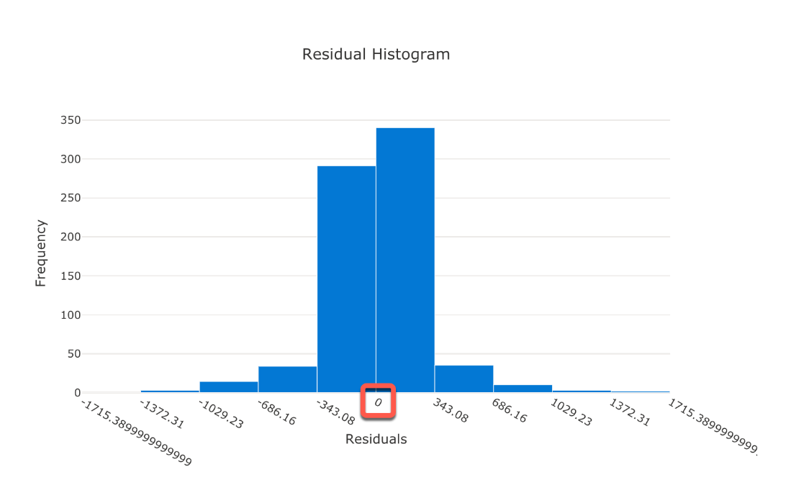

 All other options are incorrect.

For more information about Azure ML Residual histogram, please visit the below URL-

* <https://docs.microsoft.com/en-us/learn/modules/use-automated-machine-learning/use-auto-ml>.

### **Question 42**

Unattempted

Domain :Describe fundamental principles of machine learning on Azure

You need to create a new pipeline to train a regression model using Azure ML Designer. You ingest your data for the model and drop it on the canvas.

What module would you typically drag-and-drop next on the canvas?

]A.

**Train Model**

]B.

**Normalize Data**

]C.

**Select Columns in Dataset**

]D.

**Split Data**

]E.

**Clean Missing data**

**Explanation:**

**Correct Answer: C**

After we bring data for model training or ingest data, the next stage is the Data transformation. Data transformation or data pre-processing usually includes the following steps- feature selection, data cleaning, and data normalization.

In Azure ML Designer, we need to drag-and-drop the "Select Columns in Dataset" module from the Data Transformation section. Then on the right-side panel, we can select all the features we want to use for the model training.

**Microsoft Azure Machine Learning 
Pipeline-Created-on-09-22- 
Navigator 
2020 
Linear Regression 
Submit 
Q 
Publish 
O 
New 
Home 
Author 
Notebooks 
AUtomated ML 
Designer 
Assets 
Datasets 
Experiments 
pipelines 
Models 
Endpoints 
Manage 
Compute 
g Datastores 
[Z Data Labeling 
whizlabs > Designer > Authoring 
p Search by name, tags and description 
95 assets in total 
Datasets (1) 
Sample datasets (16) 
Data Input and Output (3) 
Data Transformation (19) 
Feature Selection (2) 
Statistical Functions (1) 
Machine Learning Algorithms (18) 
Model Training (4) 
Model Scoring & Evaluation (6) 
Python Language (2) 
R Language (1) 
Text Analytics (7) 
Computer Vision (6) 
Recommendation (5) 
Anomaly Detection (2) 
Web Service (2) 
85% 
bike-rentals 
Select Columns in Dataset 
Clean Missing Data 
Normalize Data 
Train Model 
Score Model 
Draft autosaved on 9/22/2020, 1:45:21 PM 
Select Columns in Dataset 
Select columns O 
Column names: 
>< 
Edit column 
Split Data 
day,mnth,year,season,holiday,weekday,workin 
gday,weathersit,temp,atemp,hum,windspeed 
Output settings 
Run settings 
Compute target O * 
@ Use default compute target O 
No compute target selected 
Select default compute target 
O Use other compute target 
Comment 
Module information **

* **Option A is incorrect** because the Train Model module usually comes after the data transformation stage.
* **Option B is incorrect** because the Normalize Data module usually comes after features selection or Select columns in Dataset.
* **Option D is incorrect** because the Split Data module usually comes after the Normalize Data block.
* **Option E is incorrect** because the Clean Missing Data module usually comes after feature selection.

For more information about Azure ML data ingestion and preparation, please visit the below URL-

* <https://docs.microsoft.com/en-us/learn/modules/create-regression-model-azure-machine-learning-designer/explore-data>.

### **Question 43**

Unattempted

Domain :Describe fundamental principles of machine learning on Azure

You trained your model and are ready to deploy.  
What steps do you need to execute for a model deployment?

Select all that apply.

A.

**Test the service**

B.

**Deploy inference pipeline**

C.

**Create compute clusters**

D.

**Create and test inference pipeline**

E.

**Create inference clusters**

F.

**Deploy training pipeline**

**Explanation:**

**Correct Answers: A, B, D and E**

After we train the model, we need to create a new production pipeline - inference pipeline. We can do this by selecting the "Real-time inference pipeline" option from the "Create inference pipeline" dropdown in Azure ML Designer with the training pipeline open.  After we create and test the inference pipeline, we need to deploy it to the created before inference AKC clusters. And finally, test the new service.

* **Option C is incorrect**. We are creating Compute clusters for the training model.
* **Option F is incorrect**. We need to deploy an inference model, not the training model.

For more information about Azure ML data model deployment, please visit the below URL-

* <https://docs.microsoft.com/en-us/azure/machine-learning/tutorial-designer-automobile-price-deploy>.

### **Question 44**

Unattempted

Domain :Describe fundamental principles of machine learning on Azure

You are creating a pipeline in Azure ML Designer. You need to add a module to execute the programming code. What languages can you use for code execution in Azure ML Designer?

Please select all that apply.

A.

**C++**

B.

**Java**

C.

**Python**

D.

**TypeScript**

E.

**C#**

F.

**R**

G.

**JavaScript**

**Explanation:**

**Correct Answers:  C and F**

Currently, you can use modules for two Languages only- Python and R.

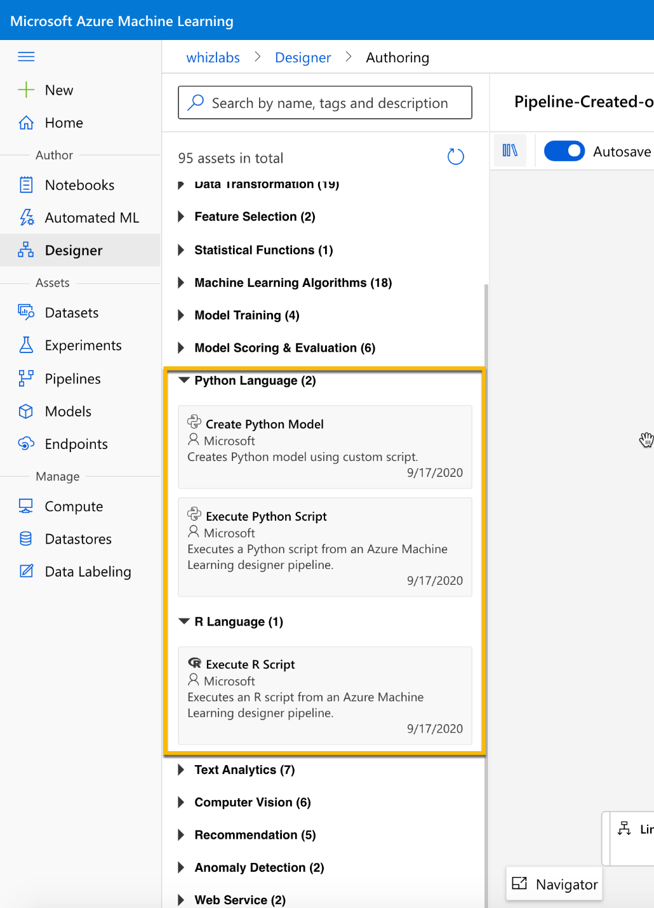

All other options are incorrect.

For more information about Azure ML Designer, please visit the below URLs-

* <https://docs.microsoft.com/en-us/azure/machine-learning/how-to-designer-python>

### **Question 45**

Unattempted

Domain :Describe features of computer vision workloads on Azure

Can you use the Object detection model for product name identification?

]A.**Yes**

]B.**No**

**Explanation:**

**Correct Answer: B**

Object detection is one of the common tasks of Computer Vision. The Object detection model helps to identify objects and their boundaries within the image. Unfortunately, there are several limitations to this service, mentioned below.

1. It can't detect the small objects (less than 5% of the image).
2. It can't detect objects that very close together, like a stack of plates.
3. It can't detect brands or product names. You can use Brand detection for this purpose.  
   Brand detection is a specialized mode of Object detection service.

For more information about Object and Brand detection, please visit the below URLs-

* <https://docs.microsoft.com/en-us/azure/cognitive-services/computer-vision/concept-object-detection>
* <https://docs.microsoft.com/en-us/azure/cognitive-services/computer-vision/concept-brand-detection>

### **Question 46**

Unattempted

Domain :Describe features of computer vision workloads on Azure

You need to identify a person using 8 MB image files in PNG format.

Can you use the Person Identification function of Azure Face service for this purpose?

]A.**Yes**

]B.**No**

**Explanation:**

**Correct Answer: B**

Azure Face service has a limitation on the size of input images. The image shouldn't be larger than 6 MB in any of the following formats: JPEG, PNG, GIF, and BMP.

For more information about Azure Face service, please visit the below URL-

* <https://docs.microsoft.com/en-us/azure/cognitive-services/face/concepts/face-recognition>.

### **Question 47**

Unattempted

Domain :Describe features of computer vision workloads on Azure

Please select all Azure Cognitive Face service functions.

A.

**Face Detection**

B.

**Objects Detection**

C.

**Find similar faces**

D.

**Person Identification**

E.

**Brand Identification**

F.

**Face Verification**

G.

**Image Analysis**

**Explanation:**

**Correct Answers: A, C, D and F.**

Azure Cognitive Face service currently includes these following functionalities.

Face detection, Face verification, Find similar faces, Group faces on similarities, and Person identification.

* **Option B is incorrect** because Object detection is one of the common tasks of Computer Vision, and it is not a Face service.
* **Option E is incorrect** because the Brand Identification is a specialized mode of Object detection service. It is not a Face service.
* **Option G is incorrect** because the Image Analysis is one of the common tasks of Computer Vision, and it is not a Face service.

For more information about Azure Face services, please visit the below URL-

* <https://docs.microsoft.com/en-us/azure/cognitive-services/face/overview>.

### **Question 48**

Unattempted

Domain :Describe features of Natural Language Processing (NLP) workloads on Azure

You need to identify the key points of the document.

You decide to use LUIS.

Does this decision help you to achieve your goal?

]A.**Yes**

]B.**No**

**Explanation:**

**Correct Answer: B**

Azure Text Analytics includes the Key Phrase Extraction service. This service helps to extract the key phrases from the text of the documents. This functionality is very useful when you need to create a summary or a catalogue from the document content or understand the customer reviews' key points.

Like Text Analytics, Language Understanding Intelligent Service (LUIS) is a Natural language processing service. LUIS helps understand voice or text commands. But it doesn't provide a Key Phrase Extraction service.

For more information about Key phrase extraction service, please visit the below URLs-

* <https://docs.microsoft.com/en-us/learn/modules/analyze-text-with-text-analytics-service/2-get-started-azure>
* <https://docs.microsoft.com/en-us/azure/cognitive-services/text-analytics/how-tos/text-analytics-how-to-keyword-extraction>

### **Question 49**

Unattempted

Domain :Describe features of Natural Language Processing (NLP) workloads on Azure

You have a foreign text. You want to get a Wikipedia page for the place mentioned in one of the sentences.

What services will you use to achieve your goal?

Please select all that apply.

A.

**Key Phrase Extraction**

B.

**Sentiment Analysis**

C.

**Translator Text**

D.

**Language Detection**

E.

**LUIS**

F.

**Entity Recognition**

**Explanation:**

**Correct Answers: C and F**

First, we need to translate the sentence or the text into English using the Translator Text service. Translator Text service provides a text-to-text translation between 60+ languages. You must provide information about translation languages (from and to) when you use Translator Text service.

Then we need to submit translated output to the Text Analytics Entity Recognition service. Entity Recognition service returns the list of entities. Because this service supports *entity linking,* it provides a link to Wikipedia for the identified locations.

* **Option A is incorrect** because the Key Phrase Extraction helps extract the key phrases from the documents' text. It doesn't provide text translation or entity extraction services.
* **Option B is incorrect** because the Sentiment Analysis helps analyze text and return sentiment scores. It doesn't provide text translation or entity extraction services.
* **Option D is incorrect** because the Language Detection helps detect the text's language. It doesn't provide text translation or entity extraction services.
* **Option E is incorrect** because the Language Understanding Intelligent Service (LUIS) helps understand voice or text commands. It doesn't provide text translation or entity extraction services.

For more information about Translator Text and Entity Recognition services, please visit the below URLs-

* <https://docs.microsoft.com/en-us/azure/cognitive-services/translator/translator-info-overview>
* <https://docs.microsoft.com/en-us/learn/modules/analyze-text-with-text-analytics-service/2-get-started-azure>

### **Question 50**

Unattempted

Domain :Describe features of Natural Language Processing (NLP) workloads on Azure

You need to create a language model.

What are the essential elements that you need to supply as data for your language model training?

Please select all that apply.

A.

**Verbs**

B.

**Utterances**

C.

**Intents**

D.

**Subjects**

E.

**Entities**

F.

**Knowledge domains**

**Explanation:**

**Correct Answers: B, C and E.**

For language model training, we need to provide the following key elements- **Entities**, **Intents,** and **Utterance**. We can achieve this by using the Azure Cognitive service LUIS portal.

**Entity** is the word or phrase that is the focus of the utterance, as the word "light" in the utterance "Turn the lights on.”

**Intent** is the action or task that the user wants to execute. It reflects in utterance as a goal or purpose. We can define intent as "TurnOn" in the utterance "Turn the lights on.”

**Utterance** is the user's input that your model needs to interpret, like "Turn the lights on" or "Turn on the lights".

All other options are incorrect.

For more information about Language modelling, please visit the below URL-

* <https://docs.microsoft.com/en-us/learn/modules/create-language-model-with-language-understanding/1-introduction>

### **Question 51**

Unattempted

Domain :Describe features of Natural Language Processing (NLP) workloads on Azure

What APIs does Azure Speech service provide?

Select all that apply.

A.

**Speech Synthesis**

B.

**Language Detection**

C.

**Text-to-Speech**

D.

**Text translation**

E.

**Speech Recognition**

F.

**Speech-To-Text**

**Explanation:**

**Correct Answers: C and F**

Azure Speech service provides only two APIs- Speech-to-Text and Text-to-Speech. These APIs also include speech recognition and speech synthesis functionalities.

All other options are incorrect.

For more information about Azure Speech APIs, please visit the below URL-

* <https://docs.microsoft.com/en-us/learn/modules/recognize-synthesize-speech/2-get-started-azure>.

### **Question 52**

Unattempted

Domain :Describe features of conversational AI workloads on Azure

People in your organization want to use internal Bot by Web and Microsoft Teams.

The lead developer decided to create a Web bot and Microsoft Teams Bot.

Do you agree with this decision?

]A.**Yes**

]B.**No**

**Explanation:**

**Correct Answer: B**

A typical Bot consists of the Knowledge base and Bot service as a user interface. You don’t need to create separate bots per channel. Azure Bot Service provides various channels for users to interact with the Knowledge base, like web chat, Microsoft Teams, email, and other common channels.

For more information about Bot Service channels, please visit the below URLs-

* <https://docs.microsoft.com/en-us/azure/bot-service/bot-service-manage-channels?view=azure-bot-service-4.0>.

### **Question 53**

Unattempted

Domain :Describe features of conversational AI workloads on Azure

What are the three main components you need to use to build a Personal Virtual Assistant?

A.

**Azure Speech**

B.

**Bot Framework**

C.

**Text Analytics**

D.

**Knowledge base**

E.

**Computer Vision Service**

F.

**Azure Bot Service**

**Explanation:**

**Correct Answers: B, D and F**

A Personal Virtual Assistant usually requires these three main components- Azure Bot Service, Bot Framework, and Knowledge base.

A typical Bot consists of the Knowledge base and Bot service as a user interface. Azure Bot Service provides various channels for users to interact with the Knowledge base, like web chat, Microsoft Teams, email, and other common channels.

A Personal Virtual Assistant is a more advanced Bot, and it also uses Bot Framework for its functionality extension. In the case of Virtual Assistant, Bot Framework "sits" between Azure Bot Service and Knowledge base or bases.

The Microsoft documentation provides the following illustration of Virtual Assistant.

**User 
Input 
Channels 
Azure Bot 
Service 
Devices 
Virtual Assistant 
Bot Framework 
Your Assistant 
Your Brand 
Your Personality 
Vision 
Language 
Understanding 
Knowledge 
Sources 
General 
Manuals 
Knowledge 
(PDF) 
Data Sources 
Skills 
(Customizable) 
Mail 
Points of 
Interest 
Automotive 
Tasks 
Calendar 
Other 
Type 
Adaptive 
Cards 
Speak 
Custom 
3P Assistants 
APIs 
Office Graph **

* **Options A is incorrect** because the Azure Speech helps recognize and synthesize speech, recognize and identify speakers, translate live or recorded speech. It is not an essential bot component.
* **Option C is incorrect** because the Text Analytics helps analyze text documents, detect document's language, extract key phrases, determine entities, and provide sentiment analysis.

It is not an essential bot component.

* **Options D is incorrect** because the Computer Vision service works with images. It is not an essential bot component.

For more information about Personal Assistant, please visit the below URLs-

* <https://docs.microsoft.com/en-us/azure/bot-service/bot-builder-virtual-assistant-introduction?view=azure-bot-service-4.0>

### **Question 54**

Unattempted

Domain :Describe features of conversational AI workloads on Azure

What service does provide a user interface for a Conversation AI agent?

]A.

**Azure Speech**

]B.

**Bot Framework**

]C.

**QnA Maker**

]D.

**Azure Bot Service**

]E.

**Computer Vision Service**

**Explanation:**

**Correct Answer: D**

Azure Bot Service provides a user interface and connections to the different channels for Conversation AI agents or bots.

* **Options A is incorrect** because the Azure Speech helps recognize and synthesize speech, recognize and identify speakers, translate live or recorded speech. It doesn't provide a user interface for bots.
* **Option B is incorrect** because the Bot Framework provides additional bots' capabilities, but it relies on Azure Bot Service to provide a user interface for bots.
* **Option C is incorrect** because the QnA Maker service provides knowledge base capabilities for bots, but it relies on Azure Bot Service to provide a user interface for bots.
* **Options E is incorrect** because the Computer Vision service works with images, and It doesn't provide a user interface for bots.

For more information about Conversation AI agents, please visit the below URLs-

* <https://docs.microsoft.com/en-us/learn/modules/build-faq-chatbot-qna-maker-azure-bot-service/1-introduction>

### **Question 55**

Unattempted

Domain :Describe features of conversational AI workloads on Azure

What are the two models of Bot integration with Customer support service?

A.

**Bot as a Personal Assistant**

B.

**Bot as an agent**

C.

**Integrated Bot**

D.

**Bot as a proxy**

E.

**Standalone Bot**

**Explanation:**

**Correct Answers: B and D.**

Microsoft Bot Framework supports two models of bot integration with agent engagement platforms, like Customer support service. These two models are **Bot as agent** and **Bot as a proxy**.

**Bot as agent** model integrates bot on the same level as live agents. The bot is engaged in interactions the same way as Customer support personnel. Handoff protocol regulates bot's disengagement and a transfer of user’s communication to a live person. This is the most straightforward model to implement.

The Microsoft documentation provides the following illustration of Bot as agent.

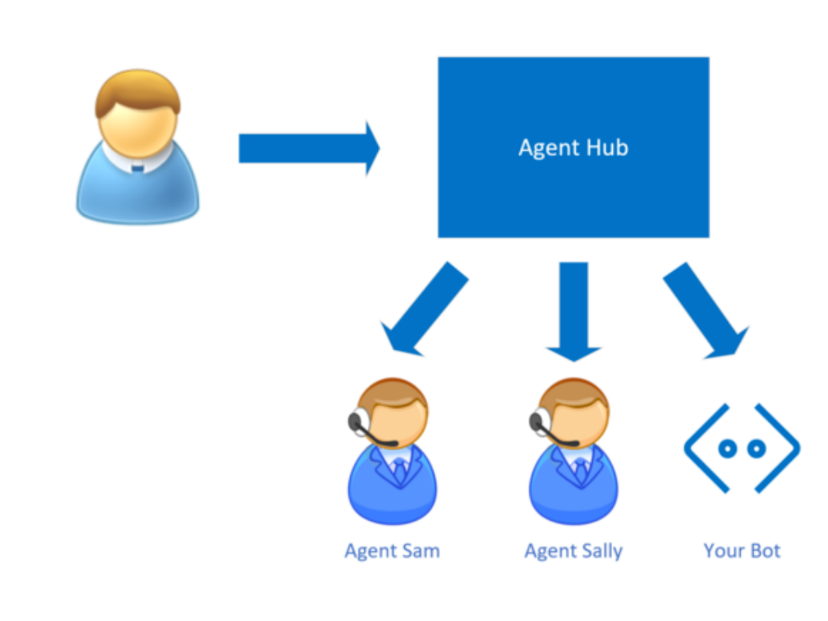

**Bot as proxy** model integrates bot as the primary filter before the user interacts with a live agent.

Bot's logic decides when to transfer a conversation and where to route it. This model is more complicated to implement.

The Microsoft documentation provides the following illustration of Bot as a proxy.

**Message Router 
YourBot 
Agent Sam AgentSallv 
Agent Hub **

All other options are incorrect.

For more information about Microsoft Bot Framework, please visit the below URL-

* <https://docs.microsoft.com/en-us/azure/bot-service/bot-service-design-pattern-handoff-human?view=azure-bot-service-4.0>.